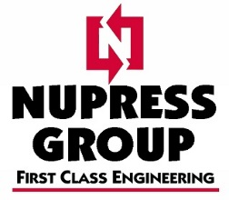

F-051-B QUALITY SYSTEMS POLICY

Nupress Tools Pty Limited is a general engineering company specialising in the design and production of precision, repetitive and general machining, fabrication and product development.

Supplying products for the Glass Wall Façade, Energy, Mining and Mineral, Aerospace and Defence, Medical and General business sectors.

‘First Class Engineering’ is the goal that Nupress Tools Pty Limited strives for. The Company’s commitment to delivery of ‘First Class’ quality products and services is achieved through the fulfillment of the following objectives:
- ‘First Class’ workmanship from our highly experienced and skilled workforce.
- A ‘First Class’ customer focus aimed at ensuring clear descriptions of all customer requirements and agreed delivery dates.
- ‘First Class’ levels of communication at all levels of business to ensure the customers’ expectations are precisely met.
- Superior management of our ‘First Class’ subcontractors and suppliers to ensure that Nupress Tools Pty Limited time, quality and cost requirements are met.
- Development of continually improving ‘First Class’ systems and procedures, which decrease the amount of rework, required due to defective product.

Nupress Tools Pty Limited’s commitment to quality is to be implemented throughout its Quality System documented to satisfy:
- AS/NZS ISO 9001:2015
- SAE AS 9100 Rev D

This policy is to be posted at all places of work for Nupress Tools Pty Limited employee’s and will be reviewed as a minimum at a bi-annual basis.

Murray Clair
Director
Nupress Tools Pty Limited
30/06/2017

